1. Change Order numbers to start from TVP2000
2. Change Date and time format
3. Make Ship Date changeable.

* Move to shiping page to change

1. Comment Box (Notes) needs to be made so users can “Chat” with each other. Must add user name to enter chat so we know who left a message at what time/date. (must connect with all other pages with comment section)
2. Change Balance to PRINT READY

* Can you explain PRINT ORDER button bellow? (number 1a)
* Function to download list custom name/number: (number 1b)
* Using list input of user when order
* Or upload manualy by yourself?
* Do we keep this page as main detail order page?
* Area ( number 2) display what image? (artwork get from order, artwork you uploaded or Proof uploaded)

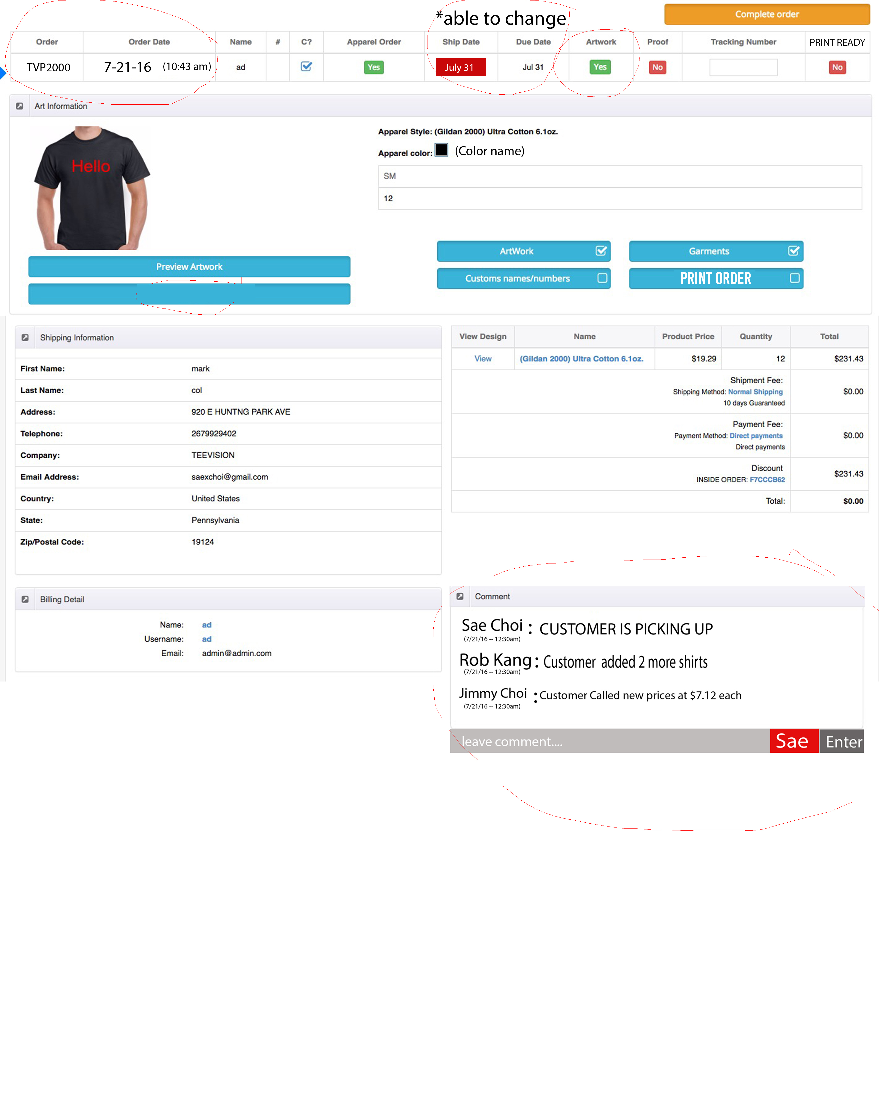

**1a**

**2**

**1b**

APPAREL (Clear)

1. Change order # to Invoice Number (able to add letters and numbers)—remove drop down menu
2. Add “ add Button” to add another invoice number
3. Remove history of different apparel orders. Only THAT one order number should have information about that apparel
4. Add Total of cost of at the end.

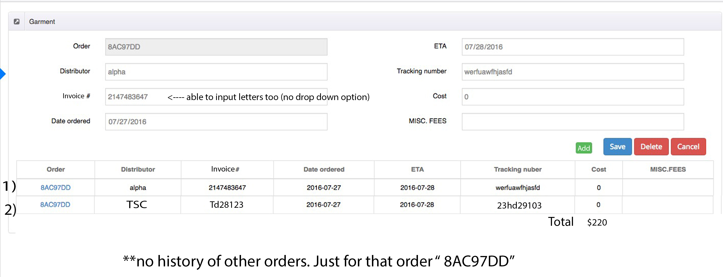

Artwork (THIS IS NEW PAGE)

* Display when click artwork button?

1. Add information about that orders garments. With name of color shirts
2. Able to manually put in how many colors of front and back
3. When adding file to save user must write name to save so we know who saved it and what time and date.

* I think you no need to write name, Can we use the login name to automaticaly add to?

1. Comment Section need for this page as well.

* Could you please explain what do delete button do? (number 3)

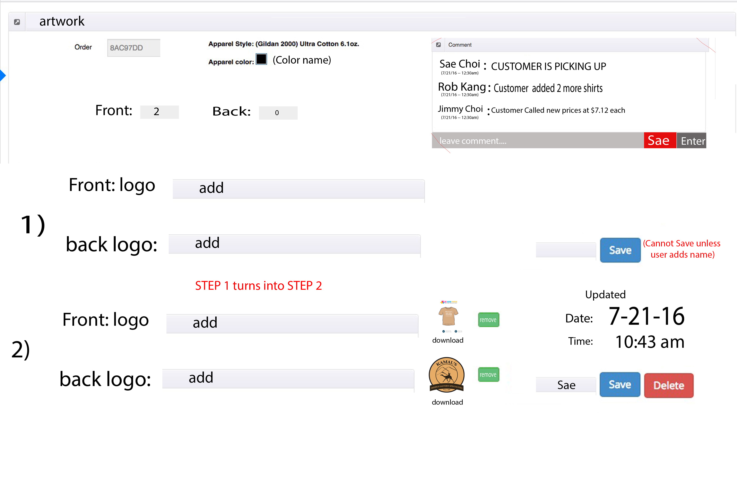

**3**

Proof (THIS IS NEW PAGE)

* Display when click Proof button?

1. *** add comment section
2. add proof with user able to save with name.

* Can we use the login name to automaticaly add to?

1. Add apprve button to change the status of proof button on main change
2. When approved – attached file is copied to PRINT READY PAGE

* Could you please explain what do delete button do?

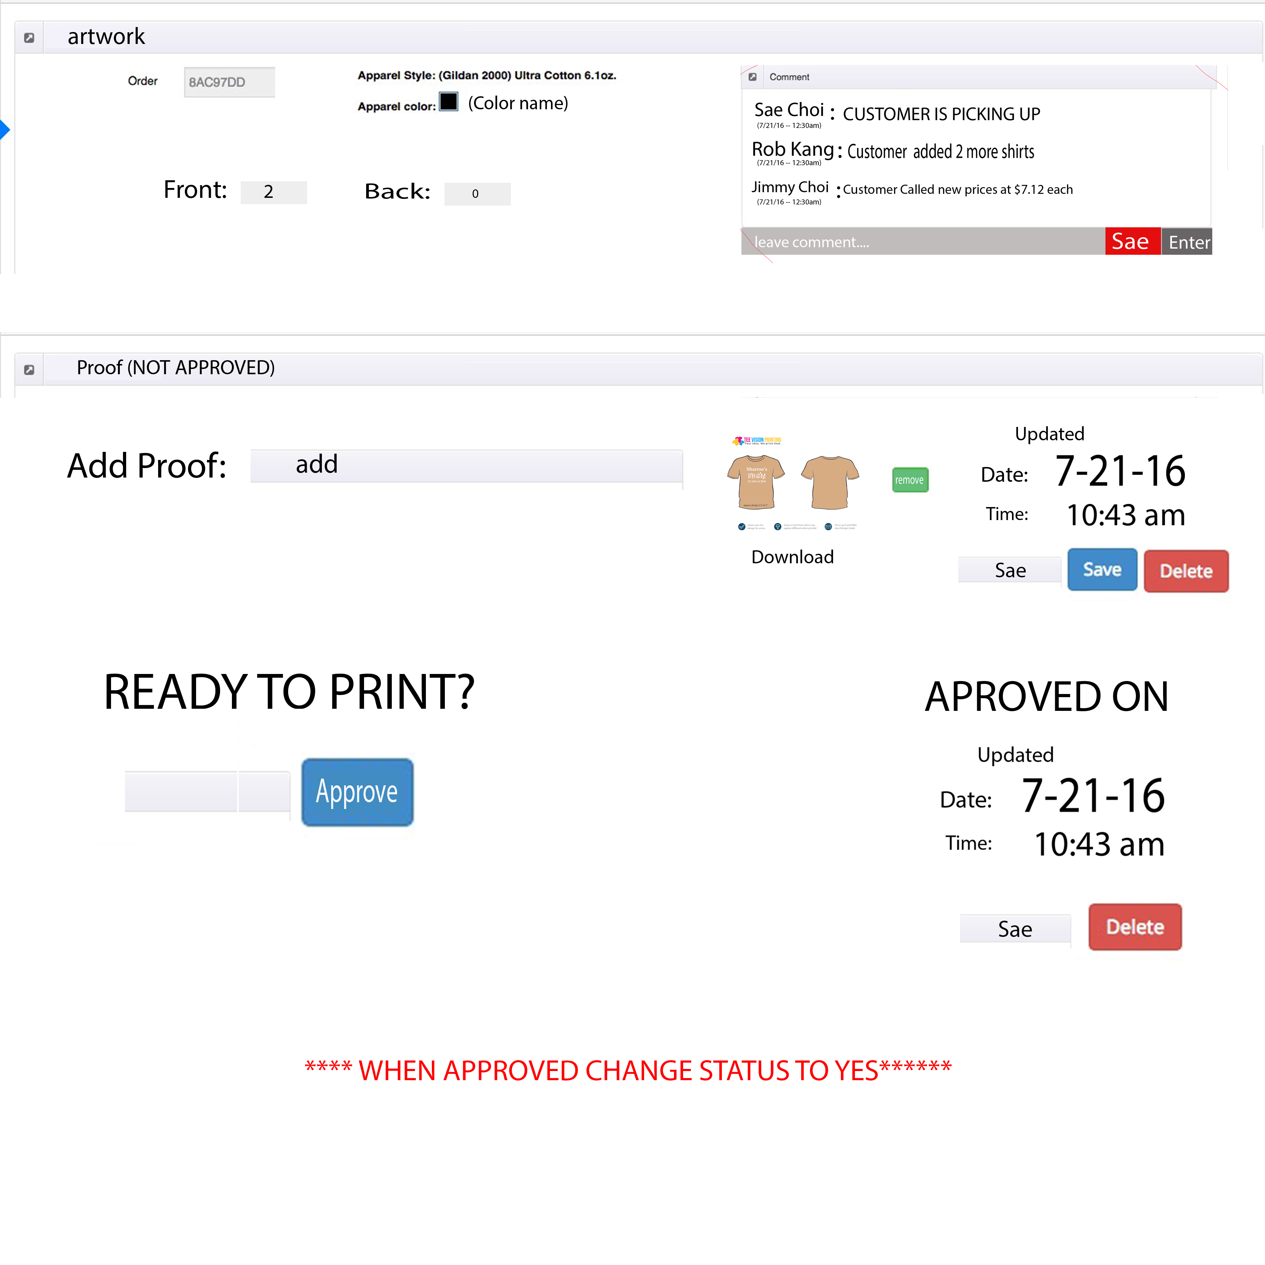

SHIP DATE (THIS IS NEW PAGE)

* Display when click Ship date button?
* How about due date?

1)---- Have the orginal Date that is set on there.

2) ---- Button for Change ( Change Date will able to change the Date to whatever date)

3)---- Button For Approve ( Approves the Date and makes the Ship Date Color Green.

4)---- When admin approves Name of user must be filled so we know who approved it.

* Can we use the login name to automaticaly add to?

5)----- When date is approved; A Date and Time is shown .

* How about due date?

6)----- Comment Box (Notes) needs to be made so users can “Chat” with each other.

7) Add Address and zip code of users onto this page

* Address and zip code input manualy or get form order shiping information?
* (number 4) Do we need show this information in this page?

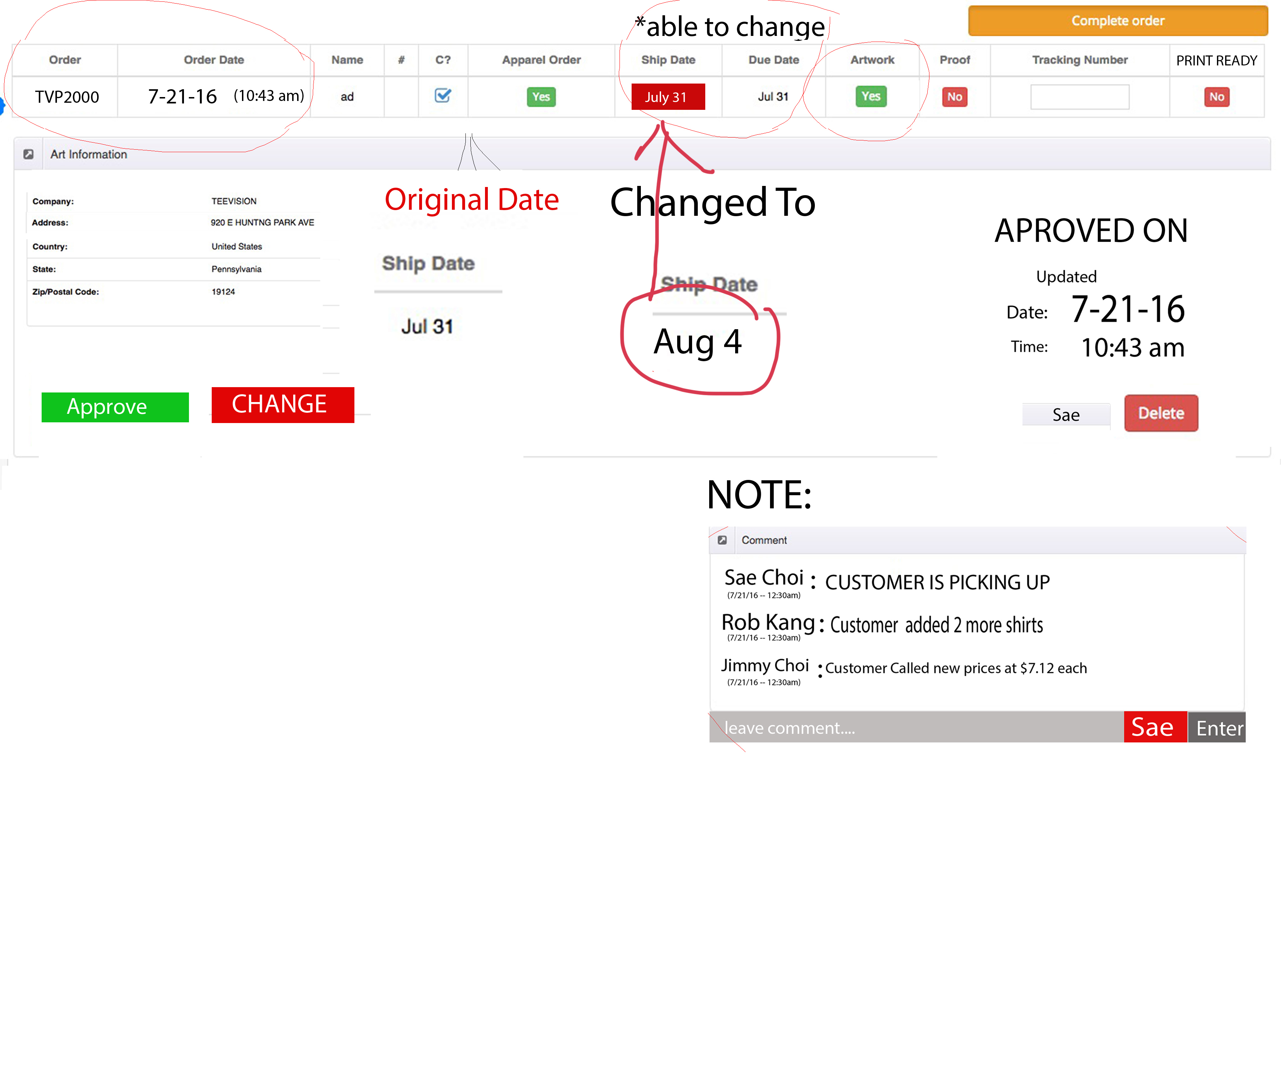

**4**

Ready to Print (THIS IS NEW PAGE)

I not clearly understand this page. Could you please explain more it,

* When click print ready -> will show this page?
* I don’t understand page 1 and page 2 meaning.

1. Only when all green buttons (apparel, ship date, artwork, proof) Print ready can be changed to green.

* This page is the main order detail or new page with only bellow information?

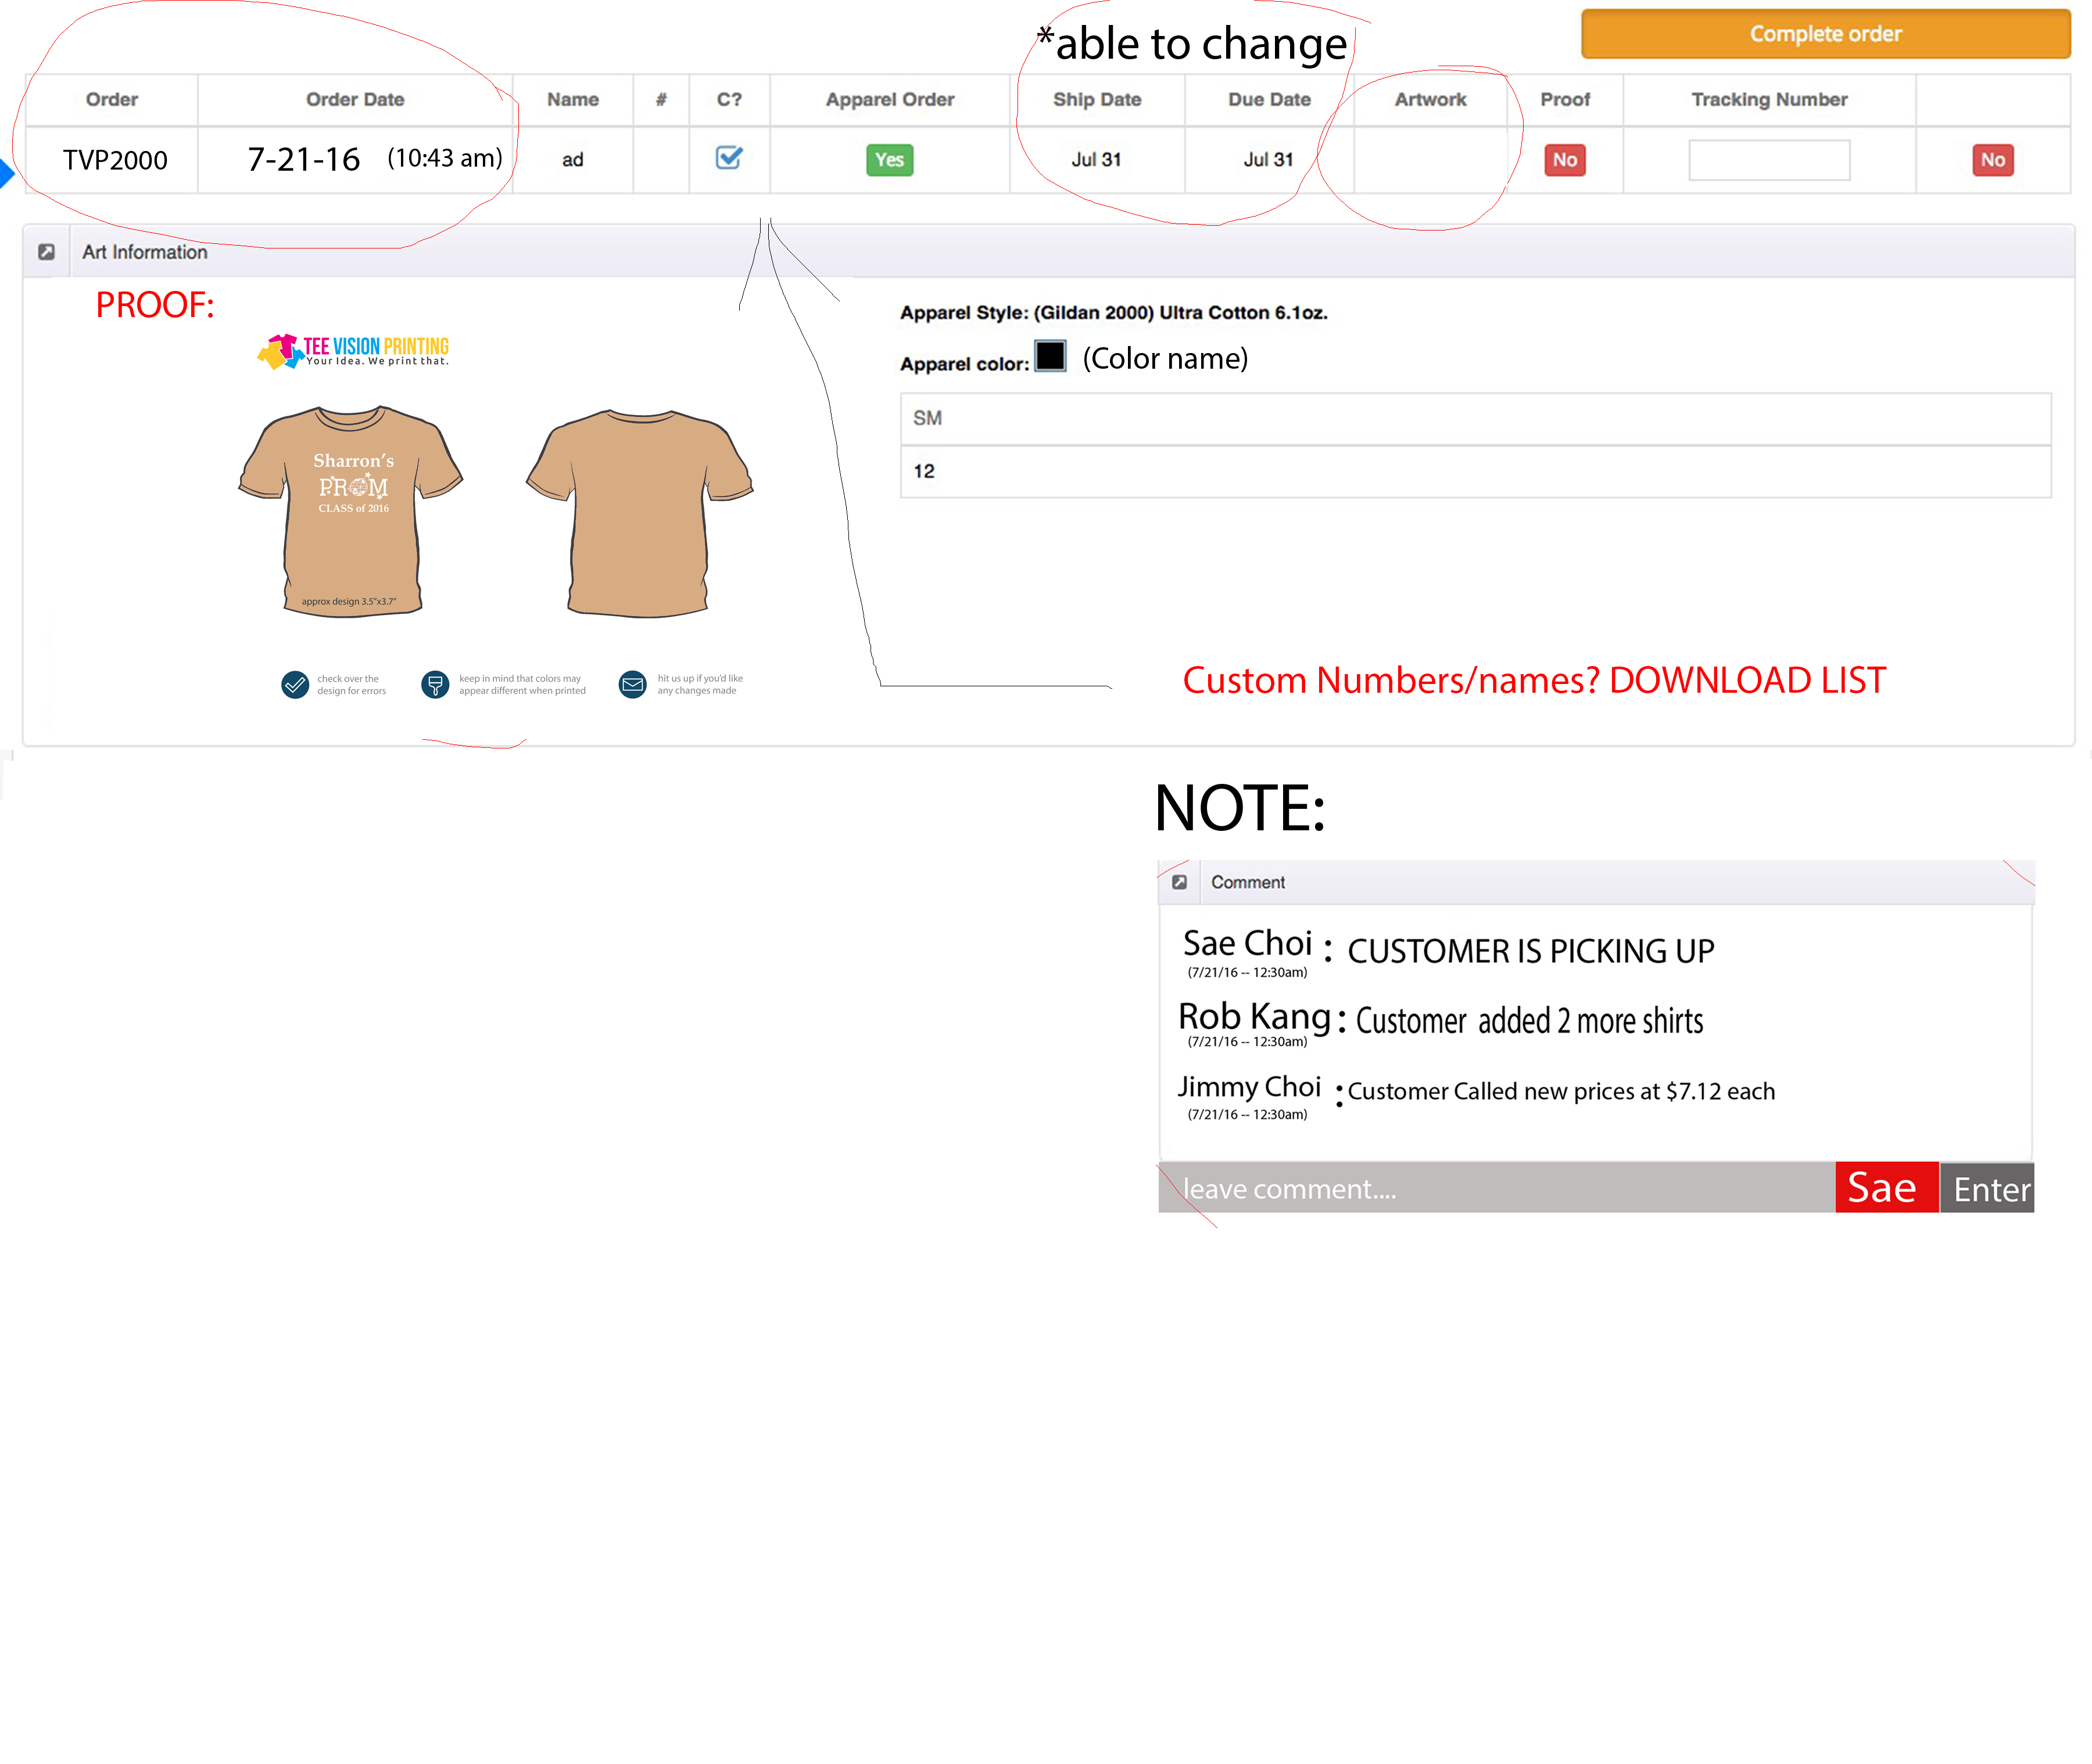

Print Out

* Clicking this button allows to print PROOF
* What button?

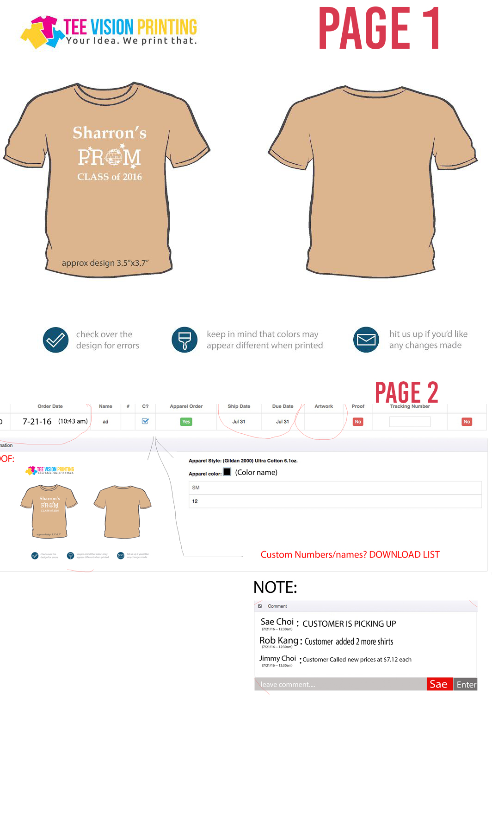

LAST THING --- COUPON DISCOUNT CODES

Able to create on Code number and not generate random numbers. No minimum total.

* We will develop this function?